QUESTION-:

Write a map reduce program to use Sequence file as input and save the output in key value output format. Note : You can use the sequence file output which you have got in the earlier assignment of the same session.

PROGRAM:

DRIVER:

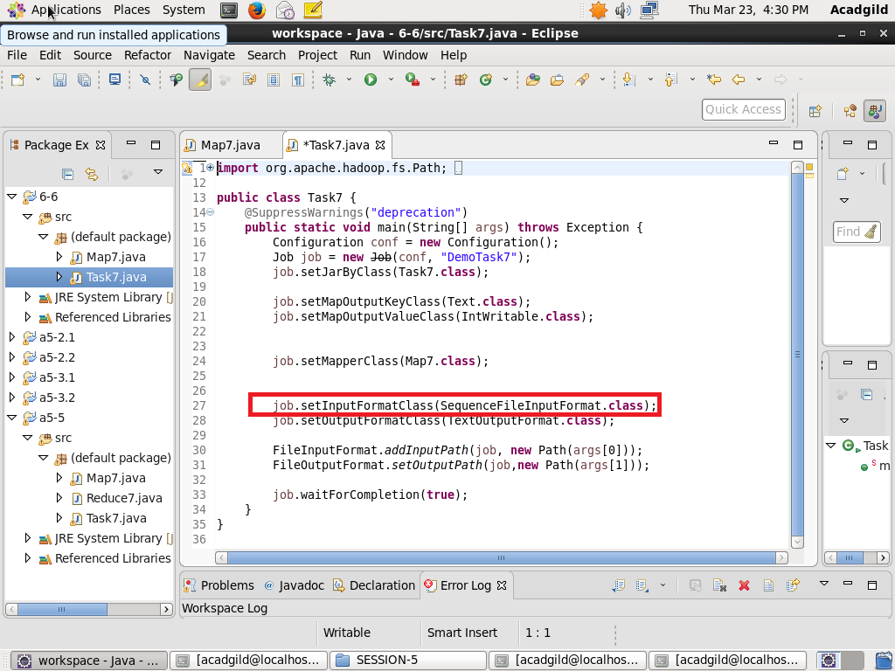

MAPPER

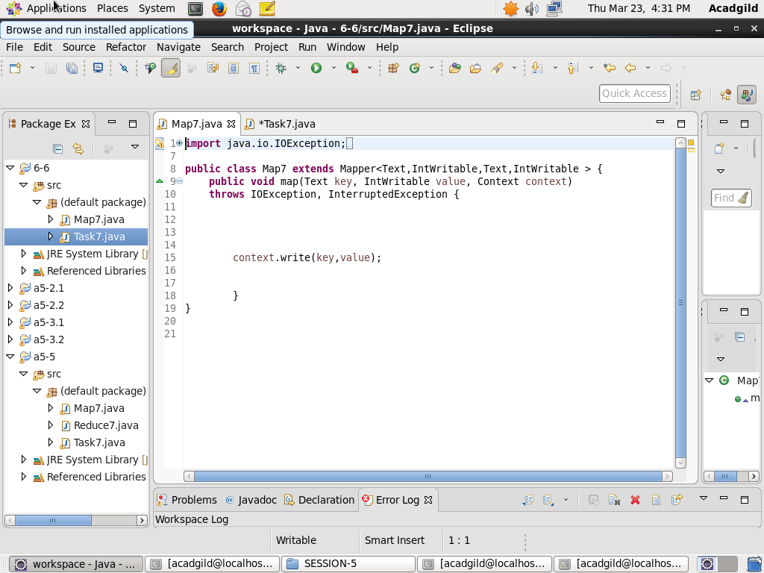

OUTPUT:

